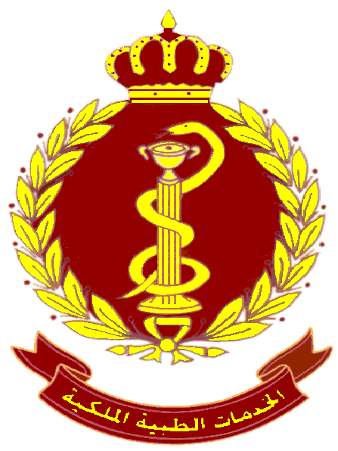

LOGBOOK OF ANGIOGRAPHIC AND INTERVENTIONAL PROCEDURES
FOR KHMC/RMC FELLOWSHIP

Name:
ID:

PERIOD: From: / /
TO: / /

Interventional Radiological Procedures
Trainees are required to perform 500 angiographic and interventional radiological procedures during a year of training. Refer to Curriculum for specific requirements.
A logbook should be kept documenting the type of examination, level of trainee participation and supervision and relevant comments about the examination including follow-up of results or ongoing management of the patient as appropriate. Each patient entry should be signed and dated by the Supervising Radiologist.

How to Use Your Log Book
The Log Book has been designed for use prospectively. It makes sense that you can only log a procedure if you have taken an active role in it: if your Supervising Consultant needs to intervene to assist you, the procedure can be logged, however, just observing a procedure is not sufficient. It is not necessary to record the exact details of your participation: the Education & Training Committee agrees this would be unnecessarily unwieldy.

